Department of Computer Science
Engineering

B.Tech III Semester
Academic Year 2026-2027
Database Management Systems(2501IT05)
Capstone Project Documentation


ADITYA UNIVERSITY
Surampalem, Kakinada District
Andhra Pradesh-533437


SCHOOL OF COMPUTING

Department of Computer Science and Engineering

CERTIFICATE

This is to certify that the Cornerstone project work entitled
“VEHICAL RENTAL MANAGEMENT SYSTEM” is submitted by

K. ABHIRAM CHANDU-25B11CS455
K.SAI SAMPATH -25B11CS364
K.SURYA PUSHKAR -25B11CS458
K.J V AVINASH -25B11CS404

in partial fulfillment of the requirements for the award of the B.Tech. degree in Computer Science and Engineering for the academic year 2026-2027.

Project Guide Head of the Department
Mrs. K Vydehi, M.Tech.,(Ph.D), Dr. Phani Sridhar , Ph.D,
Assistant Professor, Assistant Professor,
Department of CSE Department of CSE

DECLARATION

We hereby declare that the Cornerstone project entitled “VEHICAL RENTAL MANAGEMENT SYSTEM” is original and is submitted to ADITYA UNIVERSITY, Surampalem, in partial fulfillment of the requirements for the award of the B.Tech. Degree in Computer Science and Engineering. We further declare that this project work has not been submitted, either in full or in part, for the award of any degree in this or any other institution. We also confirm that this work complies with the Institutional Academic Integrity and AI Usage Policy

Place
Date:

BY

A. LAKSHMI AISHWARYA - 25B11CS011

K . AKHILA BHANU - 25B11CS472

G . LEELA RAGHINI – 25B11CS264

S. JAYA SAI MANIKANTA – 25B11CS865

ACKNOWLEDGEMENT

It is with immense pleasure that we express our sincere gratitude to our Cornerstone Project Guide, Mrs. K Vydehi, Assistant Professor, who has guided us throughout the project. Her valuable support, encouragement, and guidance have greatly contributed to the successful completion of this work.
We would like to thank our Deputy Heads of the Department, Dr. Chandra Sekhar Kolli, Associate Professor, Dr Hari Jyothula, Associate Professor and Dr Pennada Siva Satya Prasad, Assistant Profeesor, Department of Computer Science and Engineering, for their support and valuable suggestions.
Our deepest thanks to our Head of the Department Dr. Phani Sridhar Addepalli, Assistant Professor, for his inspiration and for providing all the necessary facilities and resources required for this project.
We also extend our sincere thanks to Dr. M.V. Rajesh, Associate Dean, School of Computing for their encouragement and support during the course of our project.
We would like to express our sincere gratitude to Dr.G.Suresh,Registrar Dr. A Ramesh, Pro Vice-Chancellor (Engineering & Sciences), Dr.S.RamaSree,Pro Vice-Chancellor (Academics), Dr. M.B. Srinivas, Vice-Chancellor, Dr. M. Sreenivasa Reddy, Deputy Pro Chancellor and Management, Aditya University for providing excellent infrastructure and state-of-the-art laboratories.
Finally, we would like to thank the faculty members, lab technicians, non-teaching staff, and our friends who have directly or indirectly supported us in completing this Cornerstone project successfully.

TABLE OF CONTENTS
S.No | Contents | Page No.
 | Cover Page | –
 | Certificate | –
 | Declaration | –
 | Acknowledgement | –
 | Table of Contents | 1
 | Abstract | 2
 | List of Figures | 3
 | List of Tables | 4
 | Acronyms | 5
1 | Introduction | 6-8
2 | System Analysis | 8-10
3 | Database Design | 11
4 | ER Diagram | 12
5 | Relational Schema | 13
6 | Table Design | 14-17
7 | Normalization | 18-21
8 | SQL Implementation | 22-28
9 | SQL Queries & Screenshots | 29-40
10 | Conclusion | 41
11 | Future Enhancements | 42
 | References | 43

ABSTRACT

The Pharmacy Management System is a database application designed to manage pharmacy operations in a systematic and efficient manner. The system stores and organizes information related to medicines, suppliers, customers, employees, and prescriptions through a centralized relational database. It helps maintain supplier details, pharmacy records, medicine inventories, customer information, and sales transactions. The database reduces redundancy and ensures data integrity using primary keys, foreign keys, unique constraints, NOT NULL constraints, and validation rules. SQL queries enable efficient storage, retrieval, updating, and management of pharmacy-related data. The database is normalized up to Third Normal Form (3NF) to minimize redundancy and prevent insertion, deletion, and update anomalies. The proposed system provides a structured foundation for medicine management, supplier management, customer management, employee management, prescription handling, and sales reporting, thereby supporting accurate and efficient pharmacy operations.

LIST OF FIGURES
Figure 1 | ER Diagram of Pharmacy Management System | 13

LIST OF TABLES
Table 1 | Functional Requirements | 11
Table 2 | Requirements Specification | 11
Table 3 | Major Entities | 12
Table 4 | Relationships | 12
Table 5 | Relational Schema | 14
Table 6 | Suppliers1 Table Design | 15
Table 7 | Pharmacy1 Table Design | 15
Table 8 | Medicines1 Table Design | 15
Table 9 | Customers1 Table Design | 15
Table 10 | Sales1 Table Design | 15–16
Table 11 | Prescription1 Table Design | 16
Table 12 | Prescription_Medicine1 Table Design | 16
Table 13 | Keys and Constraints | 16
Table 14 | Sales1 – Unnormalized Form (UNF) | 17
Table 15 | Sales – First Normal Form (1NF) | 18
Table 16 | Sales – Second Normal Form (2NF) | 18–19
Table 17 | Sales – Third Normal Form (3NF) | 20
Table 18 | Suppliers1 Data | 22
Table 19 | Pharmacy1 Data | 23
Table 20 | Medicines1 Data | 23
Table 21 | Customers1 Data | 24
Table 22 | Sales1 Data | 24
Table 23 | Prescription1 Data | 25
Table 24 | Prescription_Medicine1 Data | 25
ACRONYMS
- DBMS – Database Management System
- ER – Entity Relationship
- SQL – Structured Query Language
- DDL – Data Definition Language
- DML – Data Manipulation Language
- DQL – Data Query Language
- DCL – Data Control Language
- TCL – Transaction Control Language
- PK – Primary Key
- FK – Foreign Key
- 1NF – First Normal Form
- 2NF – Second Normal Form
- 3NF – Third Normal Form

1. INTRODUCTION

1.1 Brief Information about the Project
The Pharmacy Management System is a database project made to keep all the details of a pharmacy in one place. Details of suppliers, pharmacies, medicines, customers, sales and prescriptions are stored in separate tables that are linked to each other, instead of writing them in registers or in different Excel files. The project is done in SQL, and primary keys and foreign keys are used to connect the tables so that the data stays correct.

1.2 Motivation and Contribution of Project
In many small pharmacies the records are still written by hand. Because of this it takes time to find how much stock of a medicine is left, which medicines will expire soon, or what a customer bought earlier. The same customer or supplier details also get written again and again, and this leads to mistakes. We took up this project to solve these problems by keeping the data in a proper database that can be searched with simple SQL queries.
- All the pharmacy data is kept together in one database.
- Repeated data is reduced by applying normalization.
- Tables are connected using primary keys and foreign keys.
- Reports can be taken with SELECT queries that use joins, grouping and subqueries.

1.3 Objectives of the Project
- To create a database for the daily work of a pharmacy.
- To store supplier, pharmacy, medicine and customer details.
- To keep the stock quantity, price and expiry date of every medicine.
- To record the sales made to customers.
- To store prescriptions and the medicines written in them.
- To reduce duplicate data using normalization.
- To get the required information quickly using SQL queries.

1.4 Scope of the Project
This project covers the design and implementation of the pharmacy database. It includes the ER diagram, relational schema, table design, normalization, creation of tables, insertion of data and the SQL queries used to retrieve information. The project does not include a front-end screen or bill printing, but the database can be used as the back end of such an application later.

2. SYSTEM ANALYSIS

2.1 Existing System
- Records are maintained in registers or in separate Excel sheets.
- Same details are entered many times, so duplicate and wrong data is common.
- It is difficult to check the stock and the expiry date of medicines.
- Searching for records and preparing sales reports takes a lot of time.

2.2 Proposed System
In the proposed system all the data is stored in a relational database. The data is divided into tables such as Suppliers1, Pharmacy1, Medicines1, Customers1, Sales1, Prescription1 and Prescription_Medicine1. Primary keys and foreign keys connect these tables, so each detail is stored only once and can be found easily with a query.
- Supplier, pharmacy and medicine details
- Customer, sales and prescription records
- Information retrieval using SQL queries

2.3 Functional Requirements
Module | Functional Requirement
Supplier Management | Store the name, phone, email and address of each supplier.
Pharmacy Management | Store the name, phone and address of each pharmacy.
Medicine Management | Store the category, manufacturer, price, stock quantity and expiry date of medicines along with their supplier and pharmacy.
Customer Management | Store the name, phone, email and address of customers.
Sales Management | Record the customer, medicines, quantity and total amount of each sale.
Prescription Management | Store the doctor name and date of each prescription and the medicines in it.
Search and Reporting | Get the required details using SQL queries.

2.4 Non-Functional Requirements
- Performance – Queries should give results quickly for the amount of data in a pharmacy.
- Integrity – Duplicate primary key values and wrong foreign key values should not be allowed.
- Security – Only authorised users should be able to change the data.
- Usability – The tables and column names should be easy to understand.
- Scalability – The database should be able to hold more records when the pharmacy grows.

2.5 Requirements Specification
Category | Requirement
Hardware | Computer with at least 4 GB RAM and enough free disk space.
Operating System | Windows 10 or higher.
Database | Oracle SQL (data types NUMBER, VARCHAR2 and DATE are used).
Software / Tools | An SQL tool to create the tables, insert data and run the queries.

3. DATABASE DESIGN

3.1 Major Entities
Entity | Description
Suppliers | Details of the suppliers who supply medicines: ID, name, phone, email and address.
Pharmacy | Details of the pharmacy: ID, name, phone and address.
Medicines | Details of each medicine: ID, name, category, manufacturer, price, stock quantity and expiry date.
Customers | Details of the customers: ID, name, phone, email and address.
Sales | Details of the sales made to customers: sales ID, customer, medicine, quantity and total amount.
Prescription | Details of prescriptions: ID, doctor name and prescription date.
Prescription_Medicine | Weak entity that stores which medicines are written in which prescription.

3.2 ER Model
The ER model of the project has seven entities: Suppliers, Medicines, Pharmacy, Customers, Sales, Prescription and Prescription_Medicine. Each entity has a key attribute, which is underlined in the diagram. Phone of Suppliers and Pharmacy and Email of Customers are shown as multivalued attributes. Total_supplies and Total_Amount are derived attributes because they can be calculated from other data. Prescription_Medicine is a weak entity that depends on Prescription and Medicines. The entities are connected by the relationships Supplies, Has, Sold_To, Purchases and Contains.

3.3 Relationships
Relationship | Description
Suppliers – Medicines (Supplies) | One supplier can supply many medicines (1:M).
Pharmacy – Medicines (Has) | One pharmacy has many medicines (1:M).
Medicines – Customers (Sold_To) | Many medicines can be sold to a customer (M:1).
Customers – Sales (Purchases) | One customer can have many sales (1:M).
Customers – Prescription (Has) | One customer can have many prescriptions (1:M).
Prescription – Prescription_Medicine (Contains) | A prescription contains medicines, which are stored in Prescription_Medicine (M:M).

4. ER DIAGRAM
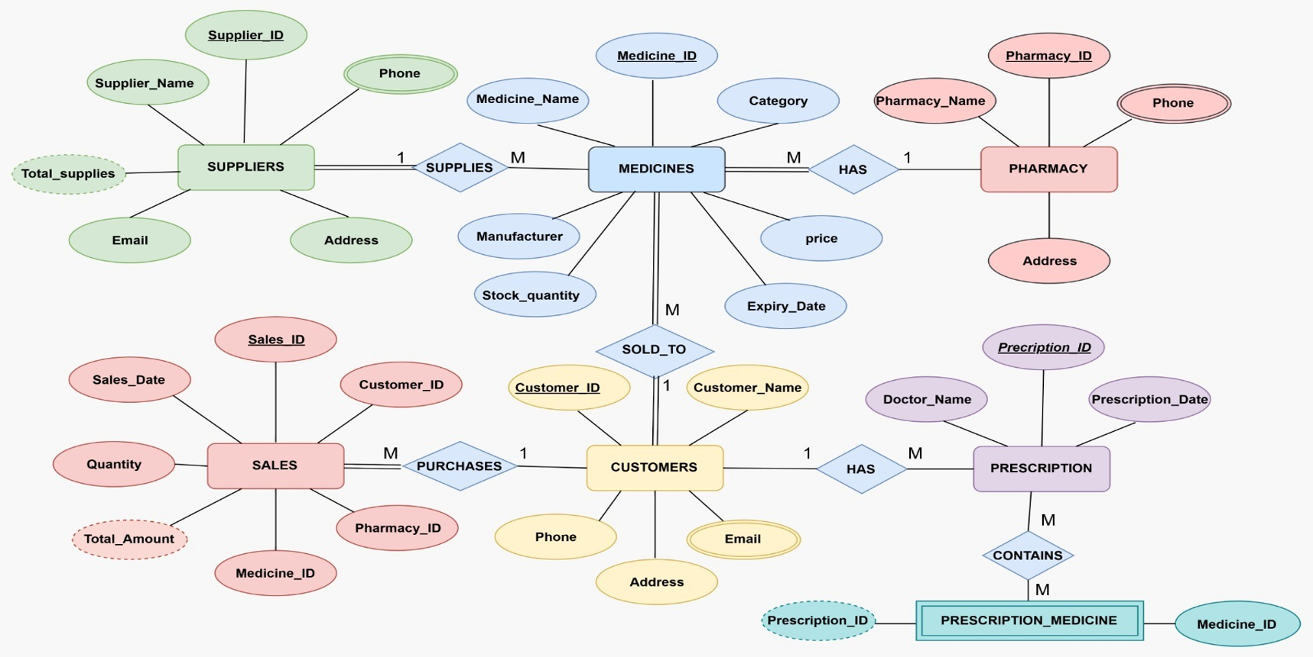
ER Diagram of Pharmacy Management System
The figure shows the ER diagram of the project. Rectangles are entities, diamonds are relationships and ovals are attributes. Underlined attributes are key attributes, double ovals are multivalued attributes and dashed ovals are derived attributes. Prescription_Medicine is drawn as a double rectangle because it is a weak entity. The numbers 1 and M near the relationships show the cardinality.

5. RELATIONAL SCHEMA
Relation | Relational Schema
Suppliers1 | Supplier_ID (PK), Supplier_Name, Phone, Email, Address
Pharmacy1 | Pharmacy_ID (PK), Pharmacy_Name, Phone, Address
Medicines1 | Medicine_ID (PK), Medicine_Name, Category, Manufacturer, Price, Stock_Quantity, Expiry_Date, Supplier_ID (FK), Pharmacy_ID (FK)
Customers1 | Customer_ID (PK), Customer_Name, Phone, Email, Address
Sales1 | Sales_ID, Customer_Name, Medicine_Name1, Medicine_Name2, Quantity, Total_Amount
Prescription1 | Prescription_ID (PK), Doctor_Name, Prescription_Date, Customer_ID (FK)
Prescription_Medicine1 | Prescription_ID (PK, FK), Medicine_ID (PK, FK)

The schema is written from the tables created in SQL. Medicines1 refers to Suppliers1 and Pharmacy1 through Supplier_ID and Pharmacy_ID. Prescription1 refers to Customers1 through Customer_ID. Prescription_Medicine1 has a composite primary key of Prescription_ID and Medicine_ID, and both of them are foreign keys. Sales1 stores the customer name and medicine names directly, so it is converted into normalized tables in Section 7.

6. TABLE DESIGN

6.1 Suppliers1 Table
Attribute | Data Type | Constraint | Description
Supplier_ID | NUMBER | PK | Unique ID of the supplier
Supplier_Name | VARCHAR2(100) | NOT NULL | Name of the supplier
Phone | VARCHAR2(15) | — | Phone number
Email | VARCHAR2(100) | — | Email address
Address | VARCHAR2(255) | — | Address of the supplier

6.2 Pharmacy1 Table
Attribute | Data Type | Constraint | Description
Pharmacy_ID | NUMBER | PK | Unique ID of the pharmacy
Pharmacy_Name | VARCHAR2(100) | NOT NULL | Name of the pharmacy
Phone | VARCHAR2(15) | — | Phone number
Address | VARCHAR2(255) | — | Address of the pharmacy

6.3 Medicines1 Table
Attribute | Data Type | Constraint | Description
Medicine_ID | NUMBER | PK | Unique ID of the medicine
Medicine_Name | VARCHAR2(100) | NOT NULL | Name of the medicine
Category | VARCHAR2(50) | — | Tablet, Capsule, Syrup or Powder
Manufacturer | VARCHAR2(100) | — | Company that makes the medicine
Price | NUMBER(10,2) | — | Price of the medicine
Stock_Quantity | NUMBER | — | Quantity available in stock
Expiry_Date | DATE | — | Expiry date
Supplier_ID | NUMBER | FK | References Suppliers1
Pharmacy_ID | NUMBER | FK | References Pharmacy1

6.4 Customers1 Table
Attribute | Data Type | Constraint | Description
Customer_ID | NUMBER | PK | Unique ID of the customer
Customer_Name | VARCHAR2(100) | NOT NULL | Name of the customer
Phone | VARCHAR2(15) | — | Phone number
Email | VARCHAR2(100) | — | Email address
Address | VARCHAR2(255) | — | Address of the customer

6.5 Sales1 Table
Attribute | Data Type | Constraint | Description
Sales_ID | NUMBER | — | ID of the sale
Customer_Name | VARCHAR2(50) | — | Name of the customer
Medicine_Name1 | VARCHAR2(100) | — | First medicine sold
Medicine_Name2 | VARCHAR2(100) | — | Second medicine sold
Quantity | NUMBER | — | Quantity sold
Total_Amount | NUMBER(10,2) | — | Total amount of the sale

6.6 Prescription1 Table
Attribute | Data Type | Constraint | Description
Prescription_ID | NUMBER | PK | Unique ID of the prescription
Doctor_Name | VARCHAR2(100) | — | Name of the doctor
Prescription_Date | DATE | — | Date of the prescription
Customer_ID | NUMBER | FK | References Customers1

6.7 Prescription_Medicine1 Table
Attribute | Data Type | Constraint | Description
Prescription_ID | NUMBER | PK, FK | References Prescription1
Medicine_ID | NUMBER | PK, FK | References Medicines1

6.8 Keys and Constraints
Constraint Type | Applied To
Primary Key | Supplier_ID, Pharmacy_ID, Medicine_ID, Customer_ID and Prescription_ID. Prescription_Medicine1 uses a composite key (Prescription_ID, Medicine_ID).
Foreign Key | Supplier_ID and Pharmacy_ID in Medicines1; Customer_ID in Prescription1; Prescription_ID and Medicine_ID in Prescription_Medicine1.
NOT NULL | Supplier_Name, Pharmacy_Name, Medicine_Name and Customer_Name.

7. NORMALIZATION
Normalization is the process of arranging the data in tables so that repeated data is removed and the same fact is not stored in more than one place. In this project normalization is applied to the Sales1 table, because it keeps the customer name as plain text and has two columns for medicine names (Medicine_Name1 and Medicine_Name2). The other tables already have a key for every row and no repeated groups.

7.1 Unnormalized Form (UNF)
Sales1 is the unnormalized table. Each row stores two medicine names in separate columns, and one quantity and one total amount for the whole sale. If a sale has a third medicine, a new column would have to be added. The table also has no primary key.
Sales1(Sales_ID, Customer_Name, Medicine_Name1, Medicine_Name2, Quantity, Total_Amount)
Data of Sales1:
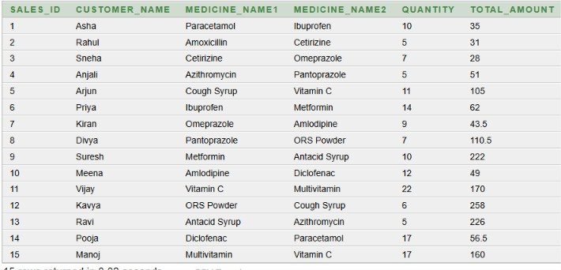

7.2 First Normal Form (1NF)
To bring the table to 1NF, the repeating columns Medicine_Name1 and Medicine_Name2 are replaced by one column Medicine_Name, and every medicine of a sale is stored in a separate row. Now all the values are single values. The primary key is (Sales_ID, Medicine_Name).
Functional dependencies:
SALES_ID → CUSTOMER_NAME, QUANTITY, TOTAL_AMOUNT
(SALES_ID, MEDICINE_NAME) → identifies each medicine entry in a sale
CREATE TABLE Sales_1NF (
Sales_ID NUMBER,
Customer_Name VARCHAR2(50),
Medicine_Name VARCHAR2(100),
Quantity NUMBER,
Total_Amount NUMBER(10,2),
PRIMARY KEY (Sales_ID, Medicine_Name)
);
Output of Sales_1NF:
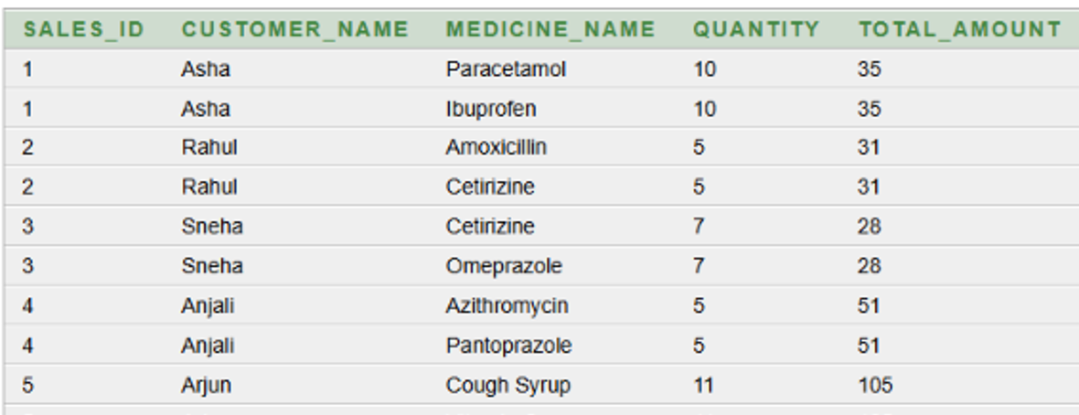

7.3 Second Normal Form (2NF)
In 1NF, Customer_Name, Quantity and Total_Amount depend only on Sales_ID, which is a part of the primary key. This is a partial dependency. To remove it, the table is split into two tables. Sales_2NF keeps the details that depend on Sales_ID, and a second table keeps the medicines of each sale.
Functional dependencies:
SALES_ID → CUSTOMER_NAME
SALES_ID → QUANTITY
SALES_ID → TOTAL_AMOUNT
(SALES_ID, MEDICINE_NAME) → identifies the sale-medicine combination
Conversion from 1NF to 2NF:
CREATE TABLE Sales_2NF (
Sales_ID NUMBER PRIMARY KEY,
Customer_Name VARCHAR2(50),
Quantity NUMBER,
Total_Amount NUMBER(10,2)
);

CREATE TABLE Sales_Medicine_2NF (
Sales_ID NUMBER,
Medicine_Name VARCHAR2(100),
PRIMARY KEY (Sales_ID, Medicine_Name)
);
Output of Sales_2NF:
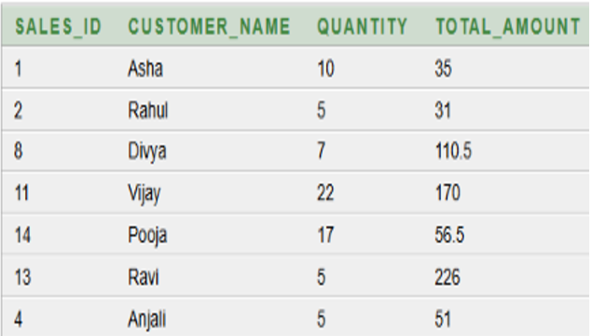
Output of the sale-medicine table:
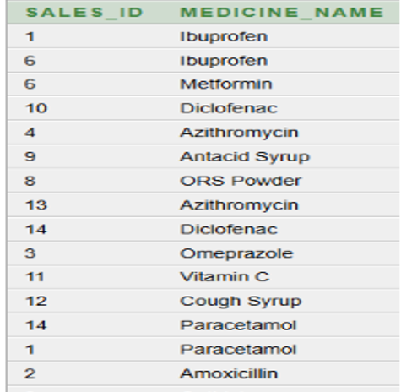

7.4 Third Normal Form (3NF)
In 2NF, the customer name is stored in the sales table, but the name depends on the customer and not on the sale. In the same way, the medicine name depends on the medicine. This is a transitive dependency. To remove it, Customer_Name is replaced by Customer_ID, which refers to Customers1, and Medicine_Name is replaced by Medicine_ID, which refers to Medicines1. Now the customer and medicine details are stored only in their own tables.
Functional dependencies:
1. SALES_ID → CUSTOMER_ID, QUANTITY, TOTAL_AMOUNT
2. CUSTOMER_ID → CUSTOMER_NAME
3. MEDICINE_ID → MEDICINE_NAME
CREATE TABLE Sales_3NF (
Sales_ID NUMBER PRIMARY KEY,
Customer_ID NUMBER,
Quantity NUMBER,
Total_Amount NUMBER(10,2),
FOREIGN KEY (Customer_ID) REFERENCES Customers1(Customer_ID)
);

CREATE TABLE Sales_Medicine_3NF (
Sales_ID NUMBER,
Medicine_ID NUMBER,
PRIMARY KEY (Sales_ID, Medicine_ID),
FOREIGN KEY (Sales_ID) REFERENCES Sales_3NF(Sales_ID),
FOREIGN KEY (Medicine_ID) REFERENCES Medicines1(Medicine_ID)
);
Output of Sales_3NF:
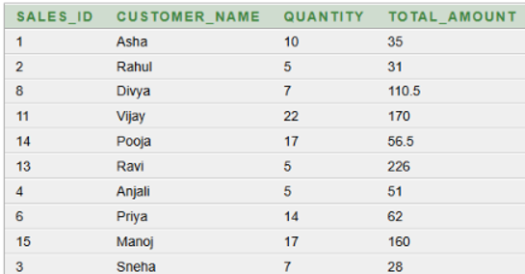
Output of the sale-medicine table:
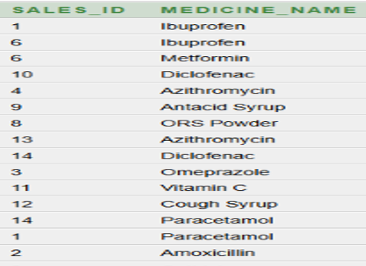

8. SQL IMPLEMENTATION

8.1 DDL – Data Definition Language
The tables of the project were created with the following CREATE TABLE statements. The tables that are referred to by foreign keys are created first.
CREATE TABLE Suppliers1(
Supplier_ID NUMBER PRIMARY KEY,
Supplier_Name VARCHAR2(100) NOT NULL,
Phone VARCHAR2(15),
Email VARCHAR2(100),
Address VARCHAR2(255)
);

CREATE TABLE Pharmacy1 (
Pharmacy_ID NUMBER PRIMARY KEY,
Pharmacy_Name VARCHAR2(100) NOT NULL,
Phone VARCHAR2(15),
Address VARCHAR2(255)
);

CREATE TABLE Medicines1 (
Medicine_ID NUMBER PRIMARY KEY,
Medicine_Name VARCHAR2(100) NOT NULL,
Category VARCHAR2(50),
Manufacturer VARCHAR2(100),
Price NUMBER(10,2),
Stock_Quantity NUMBER,
Expiry_Date DATE,
Supplier_ID NUMBER,
Pharmacy_ID NUMBER,
FOREIGN KEY (Supplier_ID) REFERENCES Suppliers1(Supplier_ID),
FOREIGN KEY (Pharmacy_ID) REFERENCES Pharmacy1(Pharmacy_ID)
);

CREATE TABLE Customers1 (
Customer_ID NUMBER PRIMARY KEY,
Customer_Name VARCHAR2(100) NOT NULL,
Phone VARCHAR2(15),
Email VARCHAR2(100),
Address VARCHAR2(255)
);

CREATE TABLE Sales1 (
Sales_ID NUMBER,
Customer_Name VARCHAR2(50),
Medicine_Name1 VARCHAR2(100),
Medicine_Name2 VARCHAR2(100),
Quantity NUMBER,
Total_Amount NUMBER(10,2)
);

CREATE TABLE Prescription1 (
Prescription_ID NUMBER PRIMARY KEY,
Doctor_Name VARCHAR2(100),
Prescription_Date DATE,
Customer_ID NUMBER,
FOREIGN KEY (Customer_ID) REFERENCES Customers1(Customer_ID)
);

CREATE TABLE Prescription_Medicine1 (
Prescription_ID NUMBER,
Medicine_ID NUMBER,
PRIMARY KEY (Prescription_ID, Medicine_ID),
FOREIGN KEY (Prescription_ID) REFERENCES Prescription1(Prescription_ID),
FOREIGN KEY (Medicine_ID) REFERENCES Medicines1(Medicine_ID)
);

8.2 DML – Data Manipulation Language
After creating the tables, 15 records were inserted into each table using INSERT statements. The data of every table is shown below. It was displayed with the SELECT * FROM command.
8.2.1 Suppliers1 Table
SELECT * FROM Suppliers1;
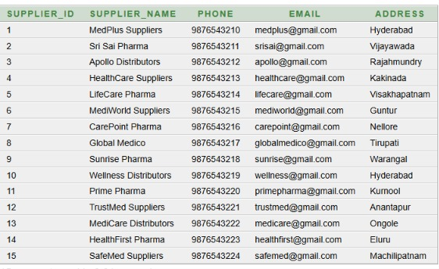
8.2.2 Pharmacy1 Table
SELECT * FROM Pharmacy1;
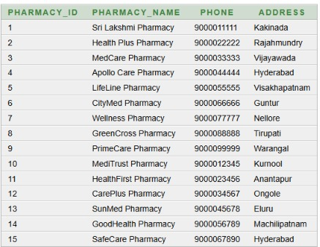
8.2.3 Medicines1 Table
SELECT * FROM Medicines1;
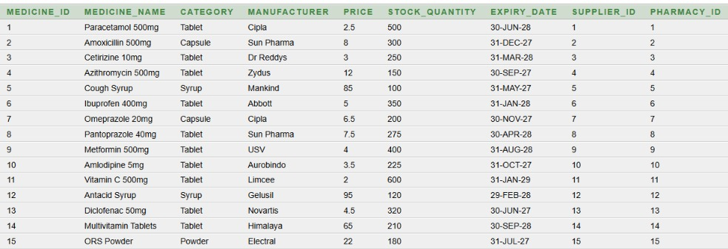
8.2.4 Customers1 Table
SELECT * FROM Customers1;
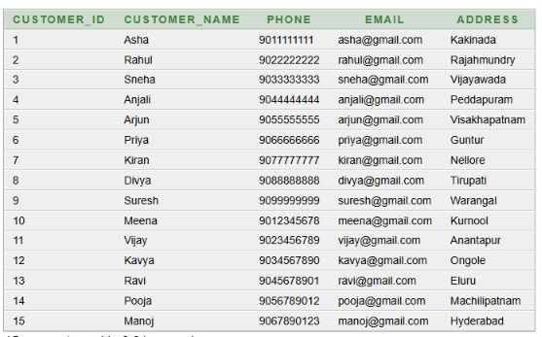
8.2.5 Sales1 Table
SELECT * FROM Sales1;
8.2.6 Prescription1 Table
SELECT * FROM Prescription1;
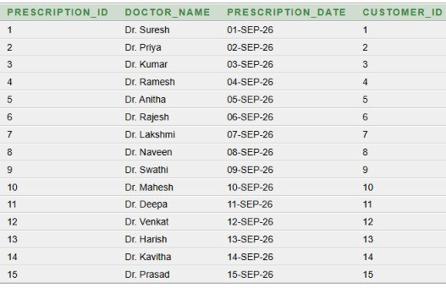
8.2.7 Prescription_Medicine1 Table
SELECT * FROM Prescription_Medicine1;
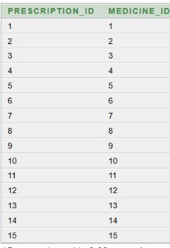

8.3 DQL – Data Query Language
Data is retrieved from the tables using SELECT statements. The basic and advanced queries that were run on the database, with their outputs, are given in Section 9.

9. SQL QUERIES & OUTPUTS
This section gives the queries that were run on the project database. For every query the question, the SQL statement and the output are shown. The basic queries are in Section 9.1 and the advanced queries, which use joins, a subquery and GROUP BY, are in Section 9.2.

9.1 Basic Queries
Q1. Display all records from the Customers1 table.
SELECT * FROM Customers1;
Output:
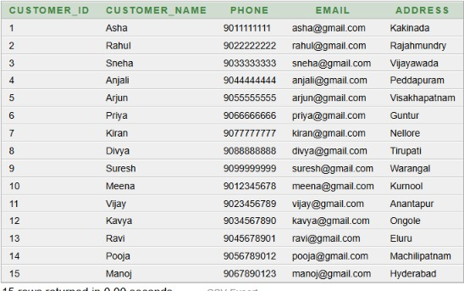
Q2. Display medicines whose price is greater than 10.
SELECT * FROM Medicines1
WHERE Price > 10;
Output:
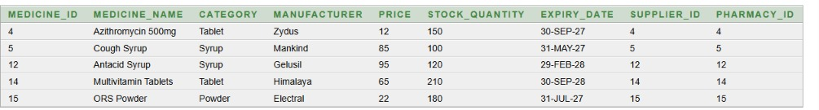
Q3. Display medicines whose stock quantity is less than 200.
SELECT * FROM Medicines1
WHERE Stock_Quantity < 200;
Output:
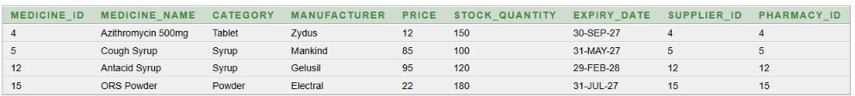
Q4. Display customers who are from Hyderabad.
SELECT * FROM Customers1
WHERE Address = 'Hyderabad';
Output:
Q5. Display medicines in ascending order of price.
SELECT * FROM Medicines1
ORDER BY Price ASC;
Output:
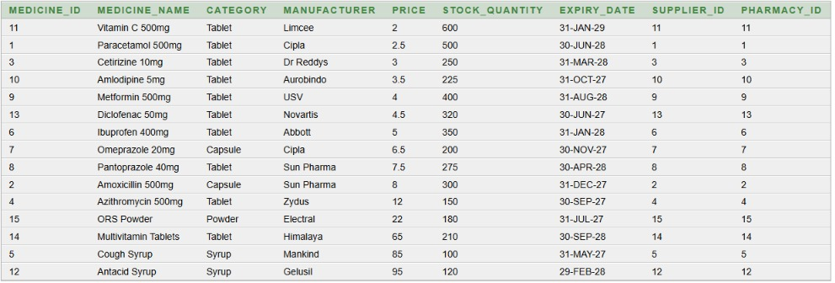
Q6. Display all records from the Prescription1 table.
SELECT * FROM Prescription1;
Output:
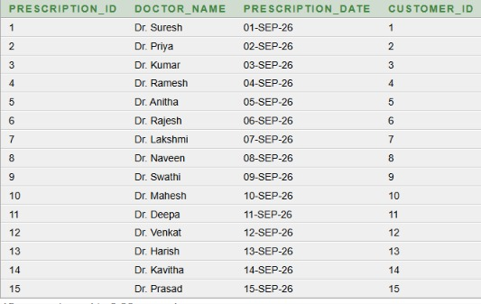
Q7. Display the total number of customers.
SELECT COUNT(*) AS Total_Customers
FROM Customers1;
Output:
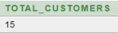

9.2 Advanced Queries
Q8. Display the customer name along with their prescription details.
SELECT C.Customer_Name,
P.Prescription_ID,
P.Doctor_Name,
P.Prescription_Date
FROM Customers1 C
JOIN Prescription1 P
ON C.Customer_ID = P.Customer_ID;
Output:
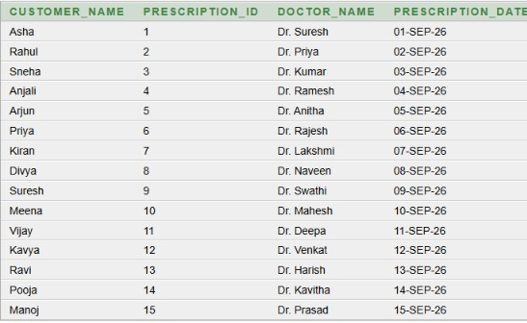
Q9. Display the medicine name along with its supplier name.
SELECT M.Medicine_Name,
S.Supplier_Name
FROM Medicines1 M
JOIN Suppliers1 S
ON M.Supplier_ID = S.Supplier_ID;
Output:
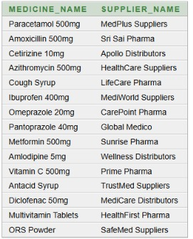
Q10. Display the medicine name along with the pharmacy name where it is available.
SELECT M.Medicine_Name,
P.Pharmacy_Name
FROM Medicines1 M
JOIN Pharmacy1 P
ON M.Pharmacy_ID = P.Pharmacy_ID;
Output:
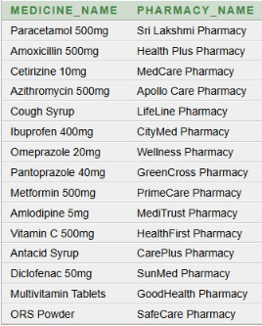
Q11. Find the most expensive medicine in the pharmacy.
SELECT Medicine_Name, Price
FROM Medicines1
WHERE Price = (SELECT MAX(Price) FROM Medicines1);
Output:
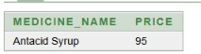
Q12. Find medicines whose price is greater than the average price of all medicines.
SELECT Medicine_Name, Price
FROM Medicines1
WHERE Price > (SELECT AVG(Price) FROM Medicines1);
Output:
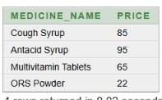
Q13. Count the number of medicines available in each category.
SELECT Category,
COUNT(*) AS Total_Medicines
FROM Medicines1
GROUP BY Category;
Output:
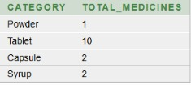
Q14. Display complete prescription details including prescription ID, customer name, doctor name and medicine name.
SELECT P.Prescription_ID,
C.Customer_Name,
P.Doctor_Name,
M.Medicine_Name
FROM Prescription1 P
JOIN Customers1 C
ON P.Customer_ID = C.Customer_ID
JOIN Prescription_Medicine1 PM
ON P.Prescription_ID = PM.Prescription_ID
JOIN Medicines1 M
ON PM.Medicine_ID = M.Medicine_ID;
Output:
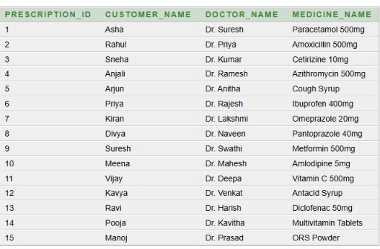

10. CONCLUSION
The Pharmacy Management System project stores the details of suppliers, pharmacies, medicines, customers, sales and prescriptions in a relational database. The tables are connected with primary keys and foreign keys, and the Prescription_Medicine1 table is used to link prescriptions with medicines. The Sales1 table was normalized up to 3NF to remove repeated data. The queries given in this document show that the required information can be taken from the database easily using SELECT statements, joins, a subquery and grouping. This database can be used as the back end for a complete pharmacy application.

11. FUTURE ENHANCEMENTS
- Adding primary key and foreign keys to the Sales table.
- Giving alerts for medicines that are low in stock or near expiry.
- Adding bill generation for every sale.
- Adding user login with different access for staff and admin.
- Making a front-end screen using a web or desktop application.
- Keeping a purchase record of the medicines bought from suppliers.

REFERENCES
- Silberschatz, Korth and Sudarshan, Database System Concepts, McGraw Hill.
- Elmasri and Navathe, Fundamentals of Database Systems, Pearson.
- Ramakrishnan and Gehrke, Database Management Systems, McGraw Hill.
- Oracle documentation, Oracle Database SQL Language Reference.

